GPU: P100

CPU = 4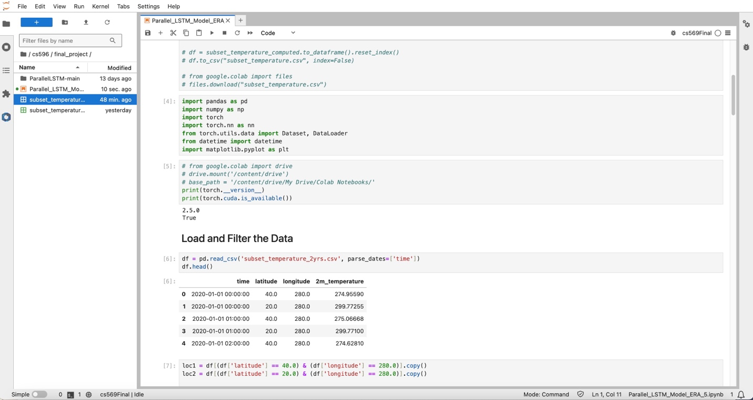

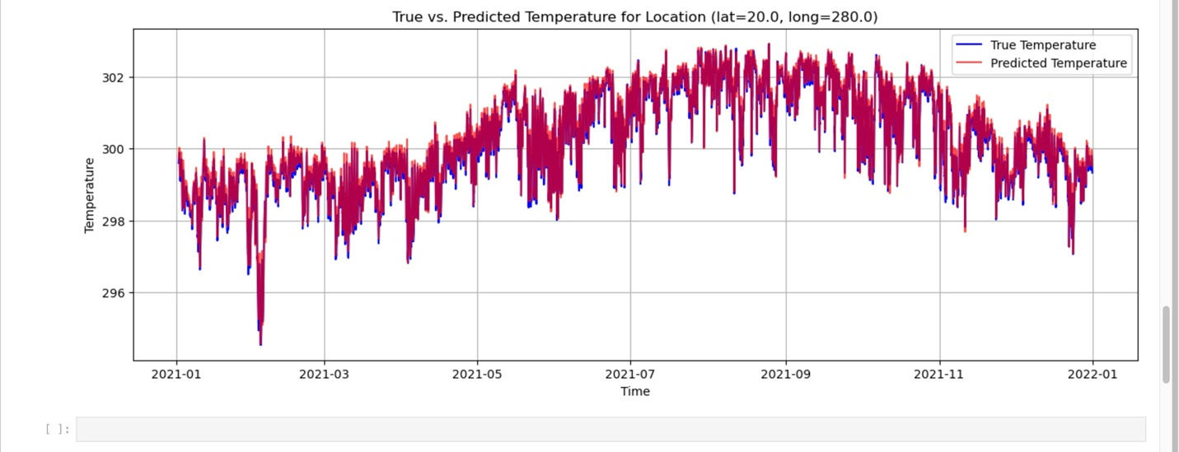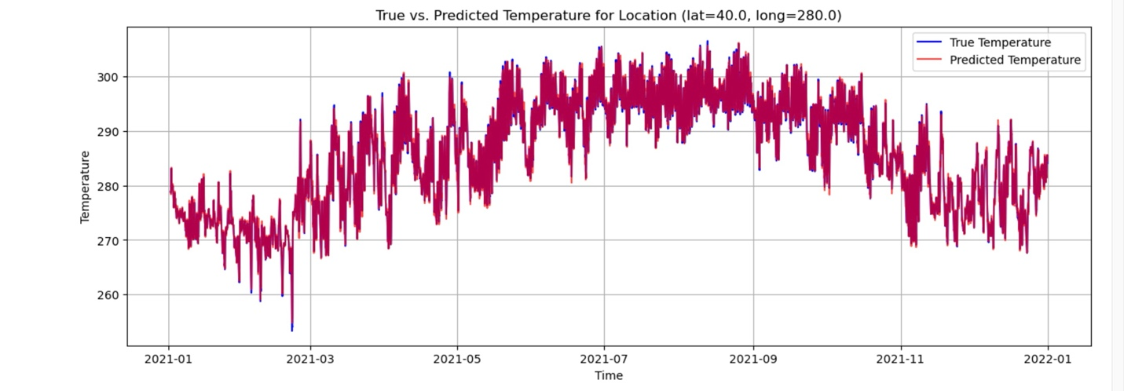

Num_worker = 1

With epoch = 20, execution time: 11.89s

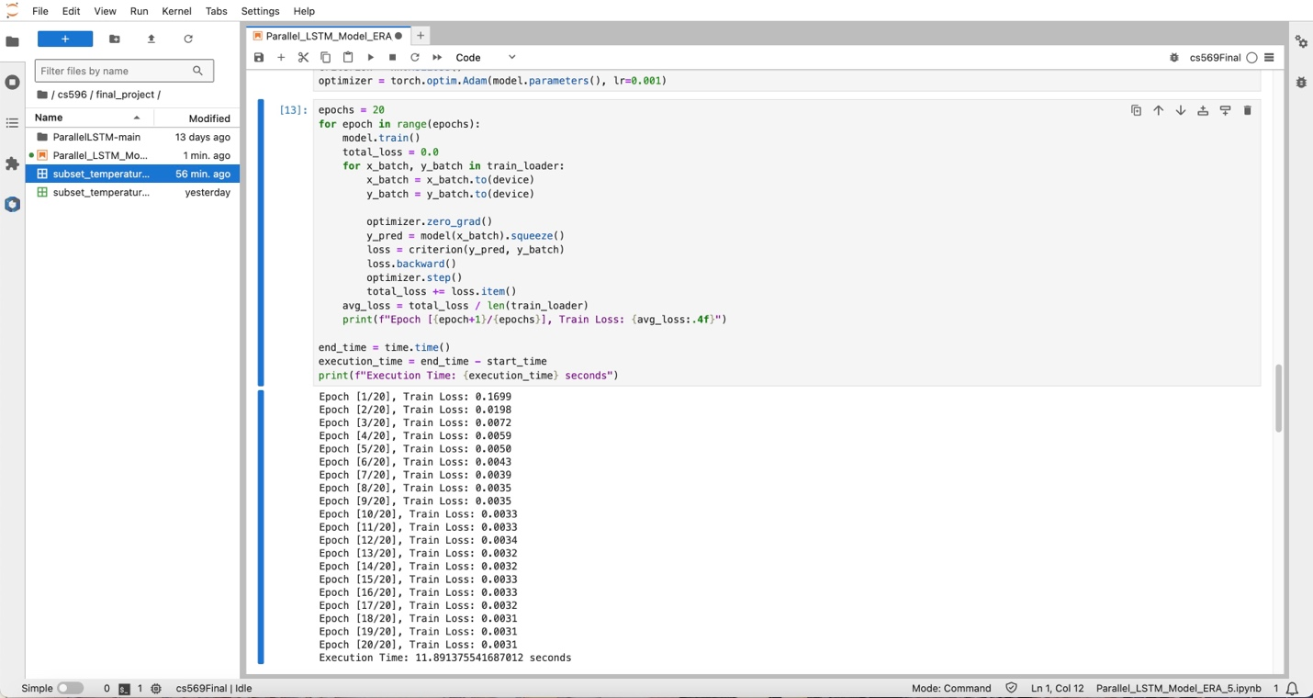

With epoch = 10, execution time: 6.88s

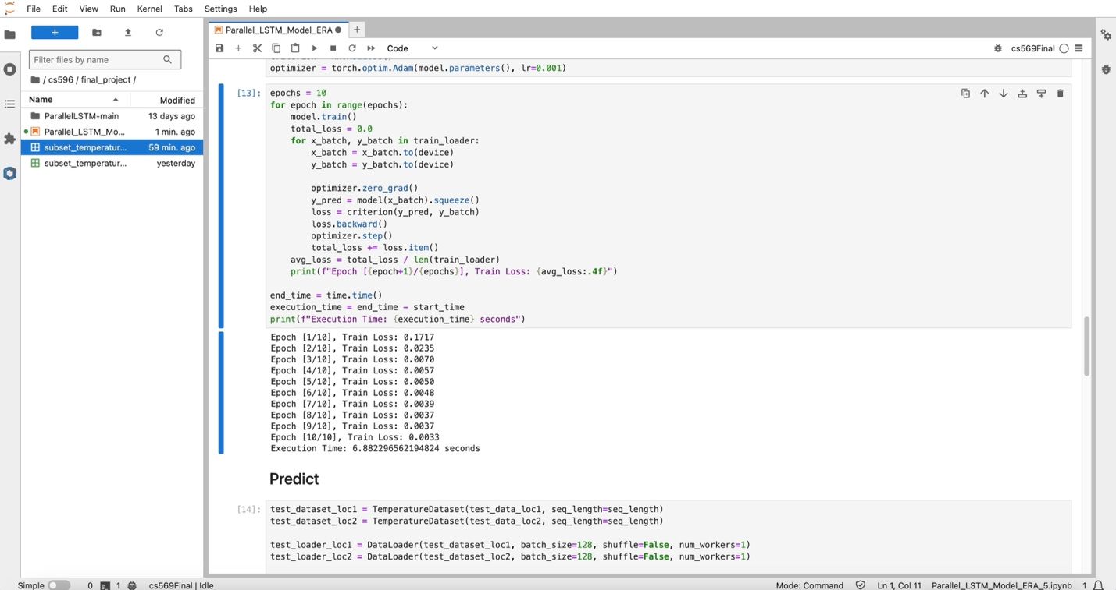

With epoch = 15, execution time: 9.30s

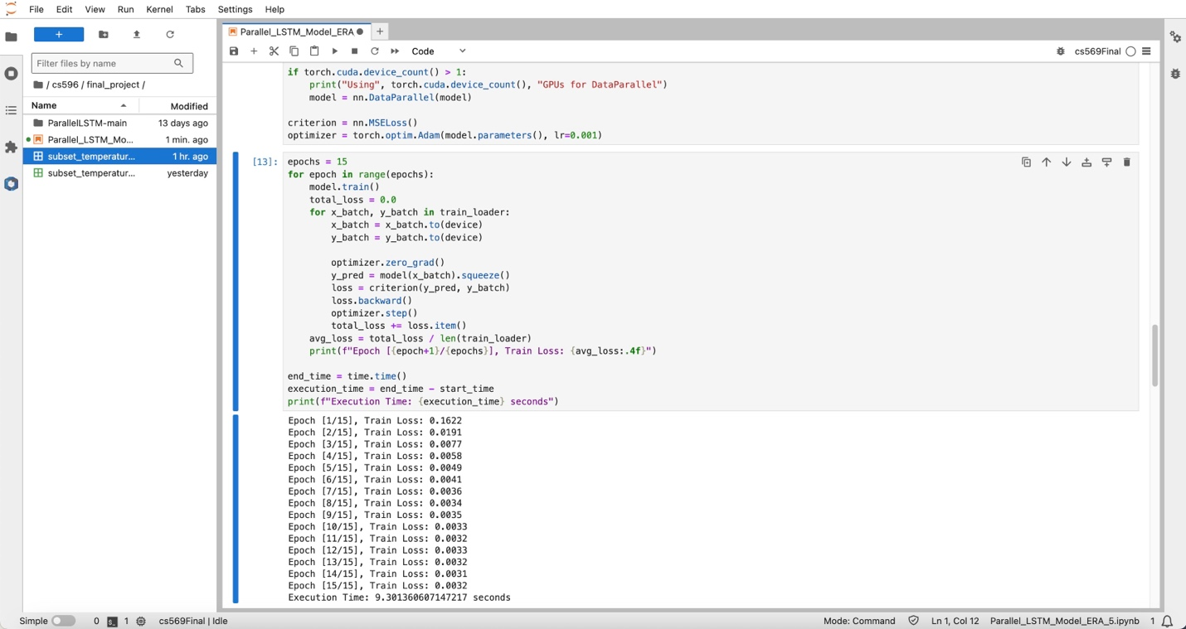

With epoch = 5, execution time: 4.28s

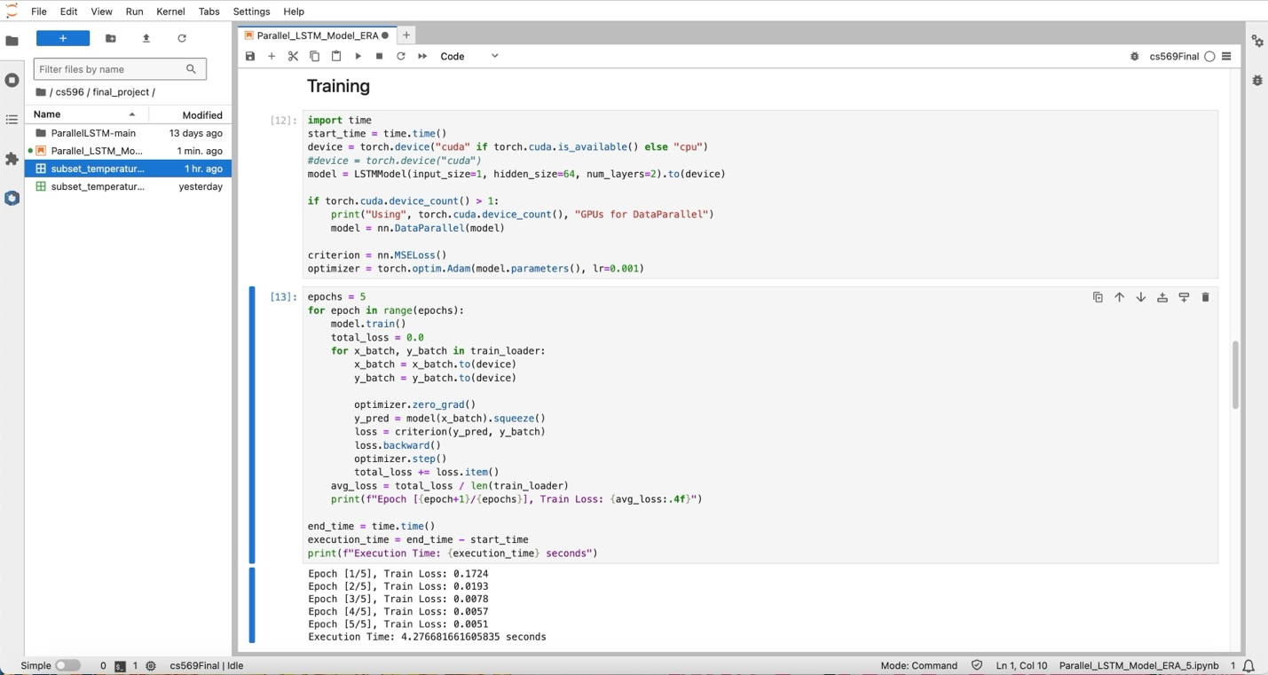

Num_worker = 2

With epoch = 20, execution time: 12.23s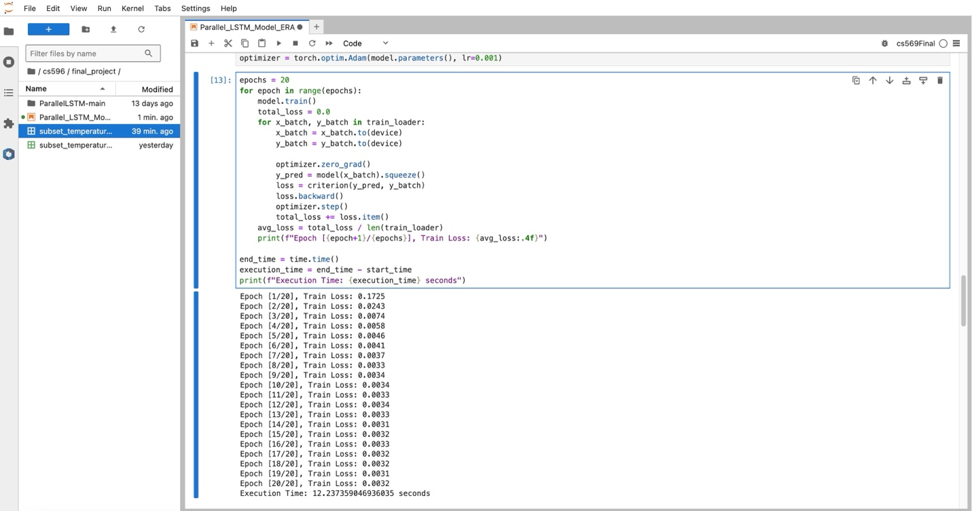

With epoch = 15, execution time: 9.50s

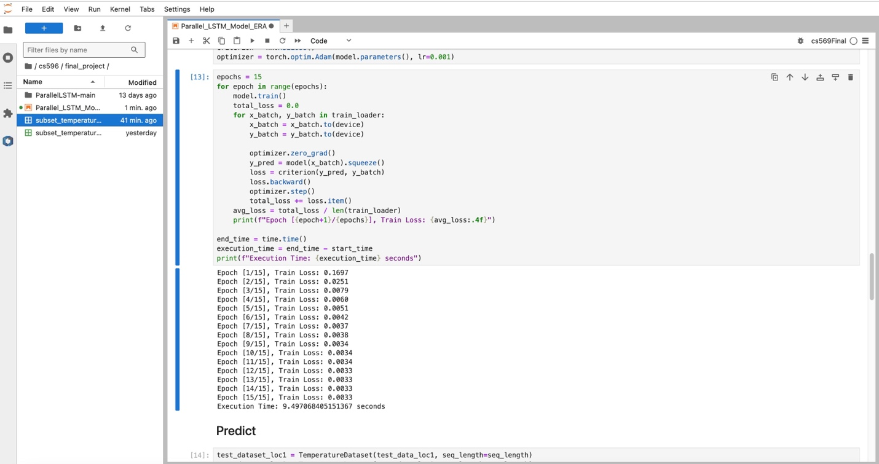

With epoch = 10, execution time: 6.90s

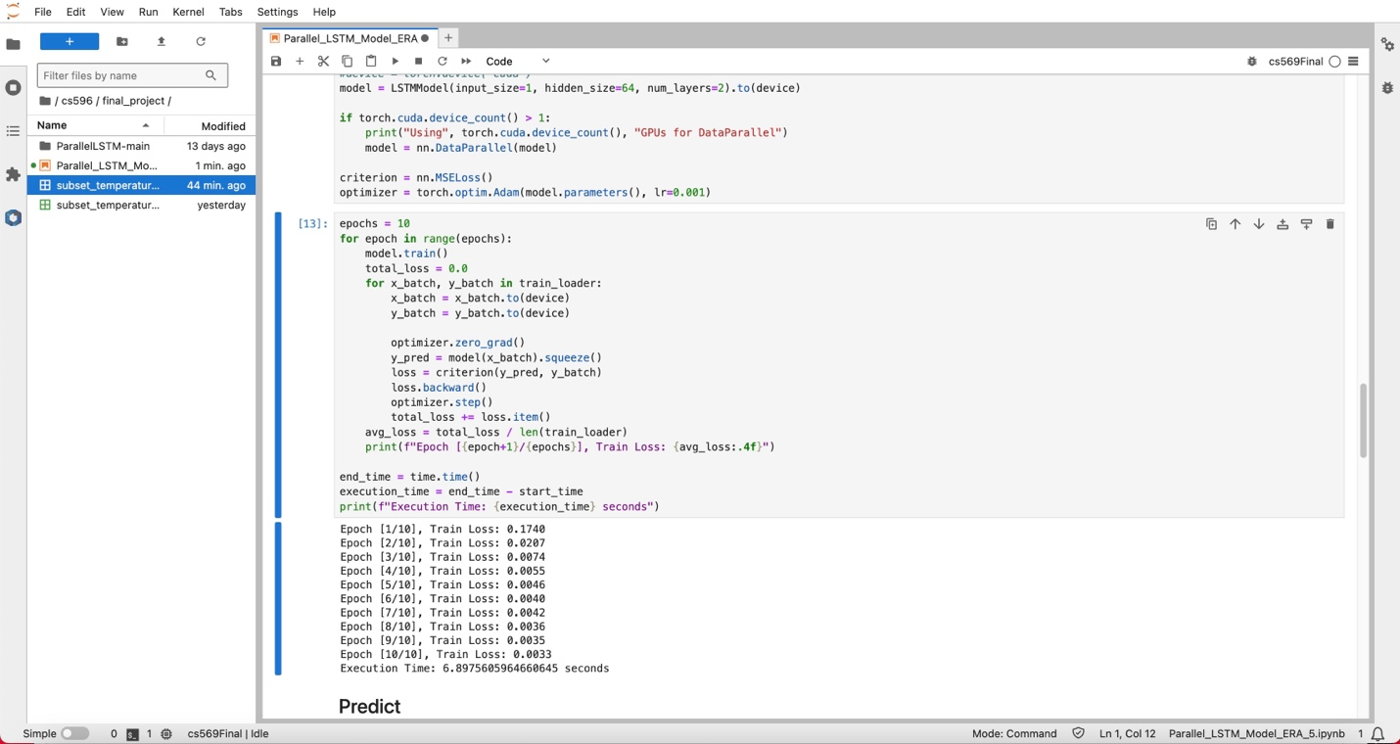

With epoch = 5, execution time: 4.27s

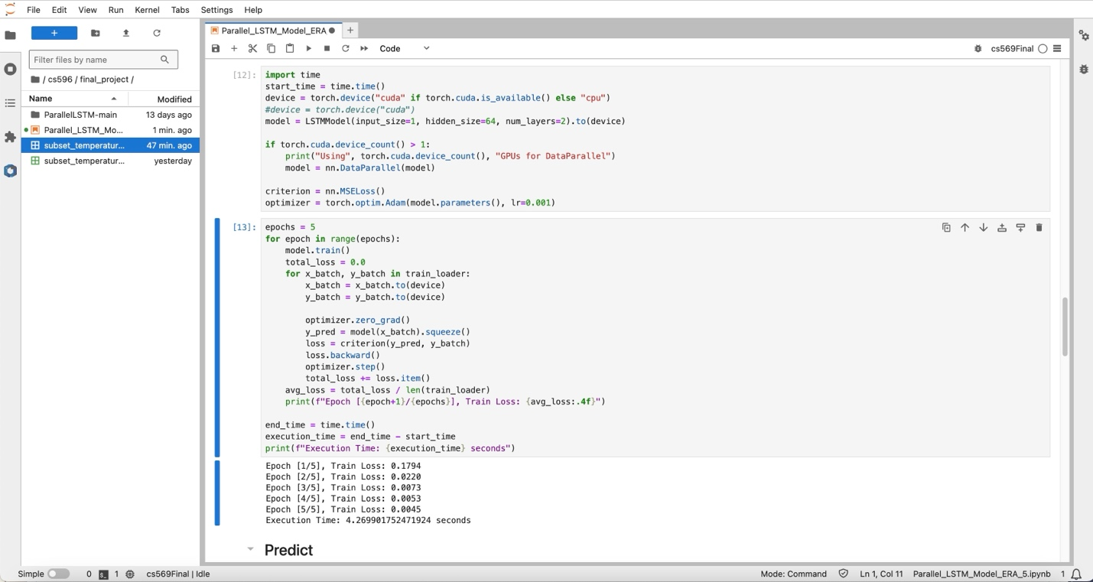

GPU: P100

CPU = 2

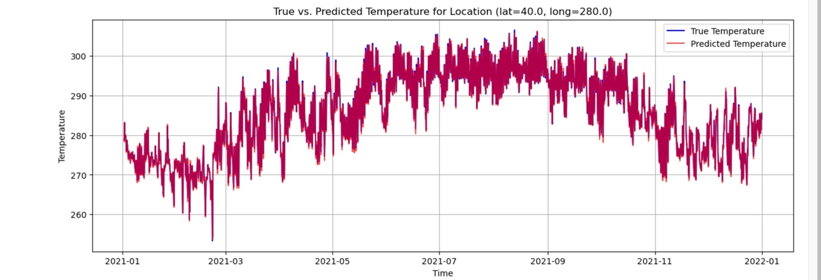

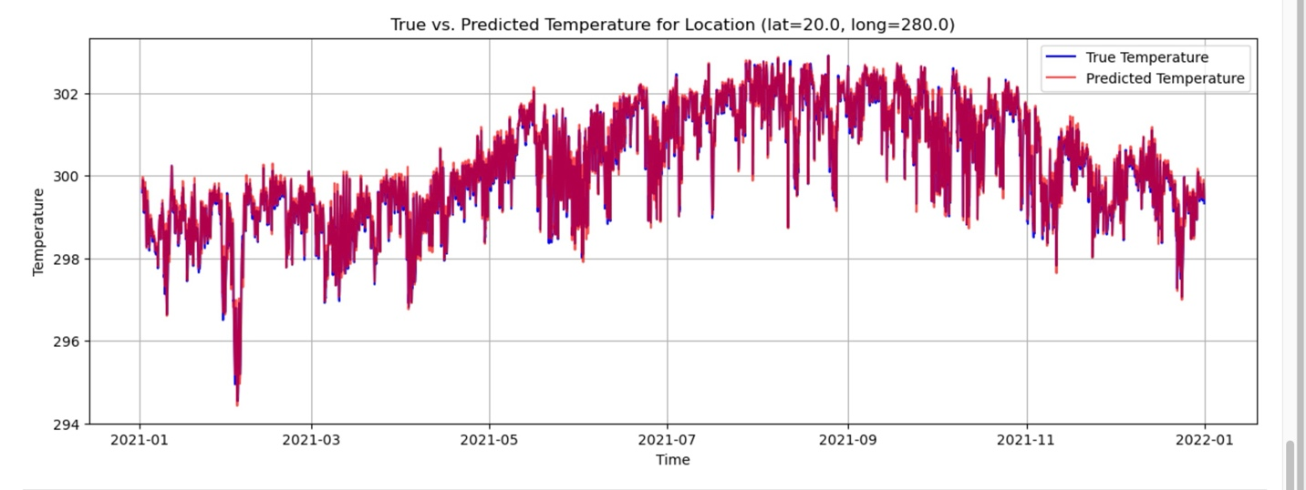

Num_worker = 1

With epoch = 5, execution time: 5.50s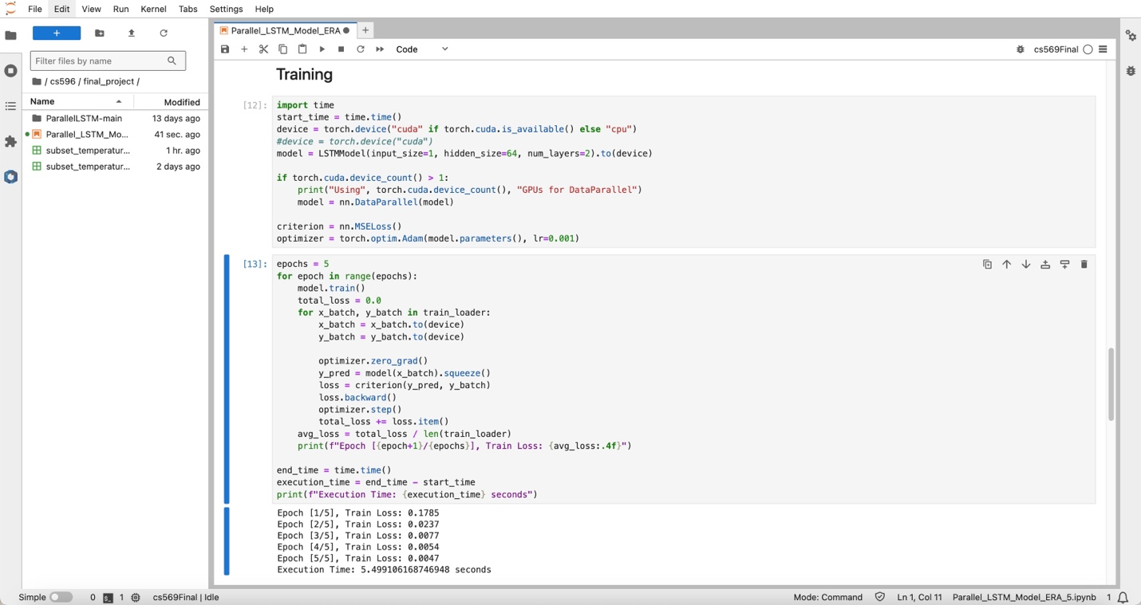

With epoch = 10, execution time: 9.74s

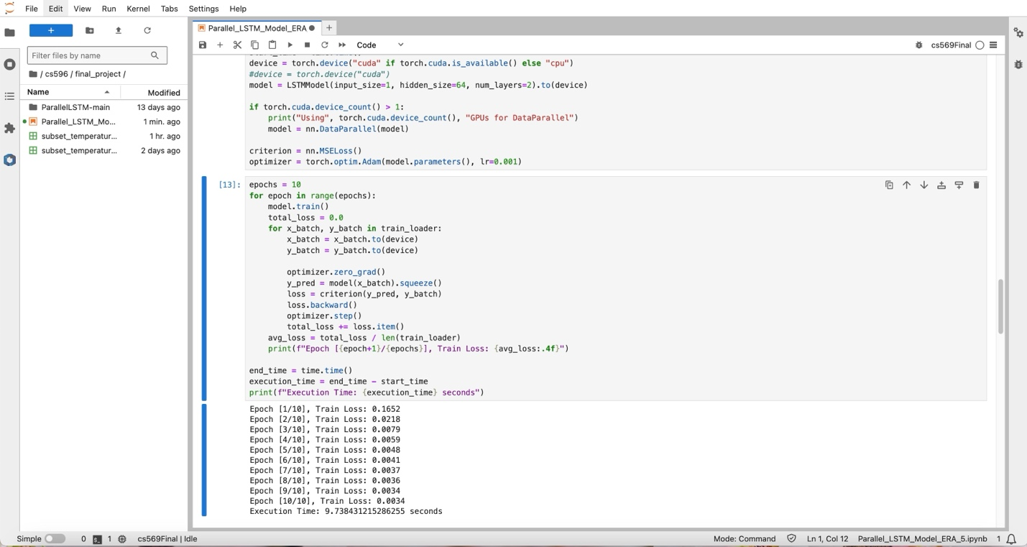

With epoch = 15, execution time: 12.85s

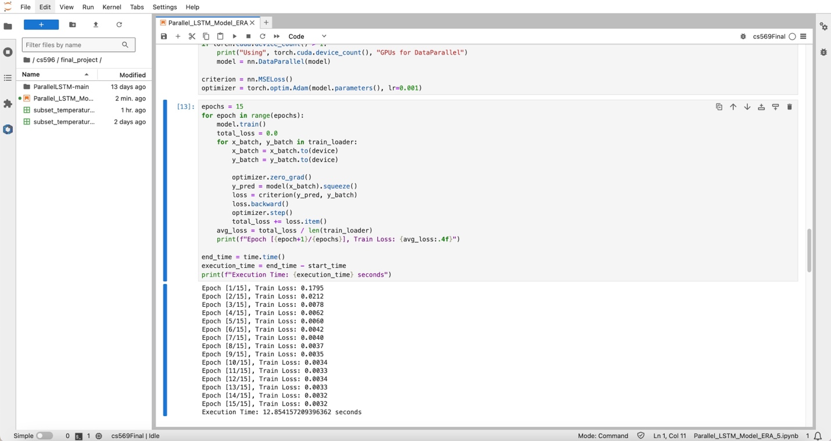

With epoch = 20, execution time: 16.41s

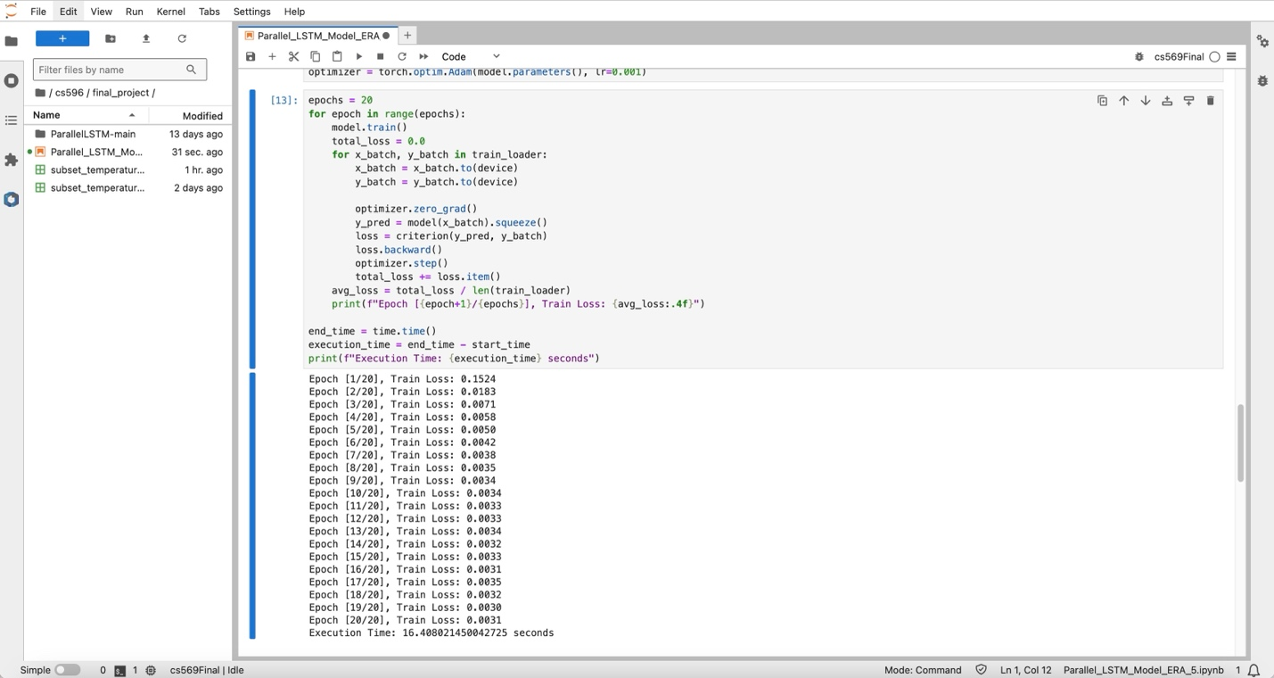

Num_worker = 2

With epoch = 5, execution time: 5.67s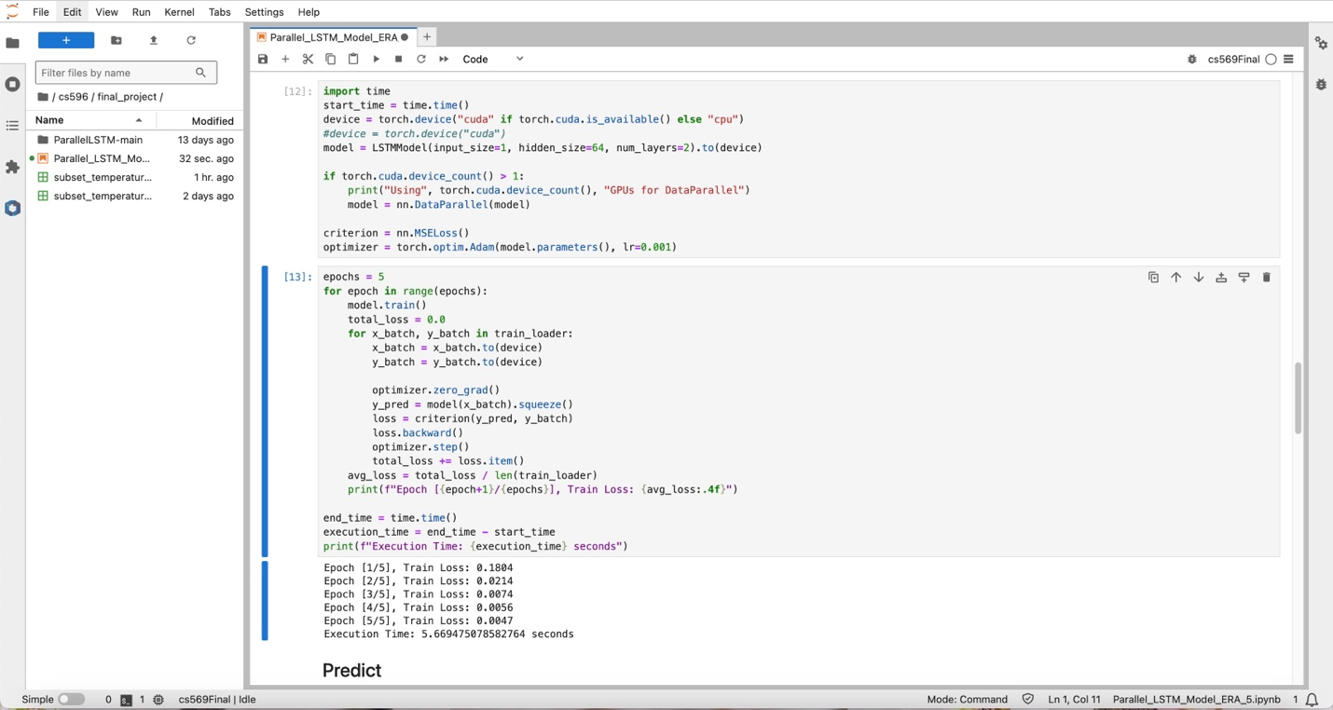

With epoch = 10, execution time: 8.61s

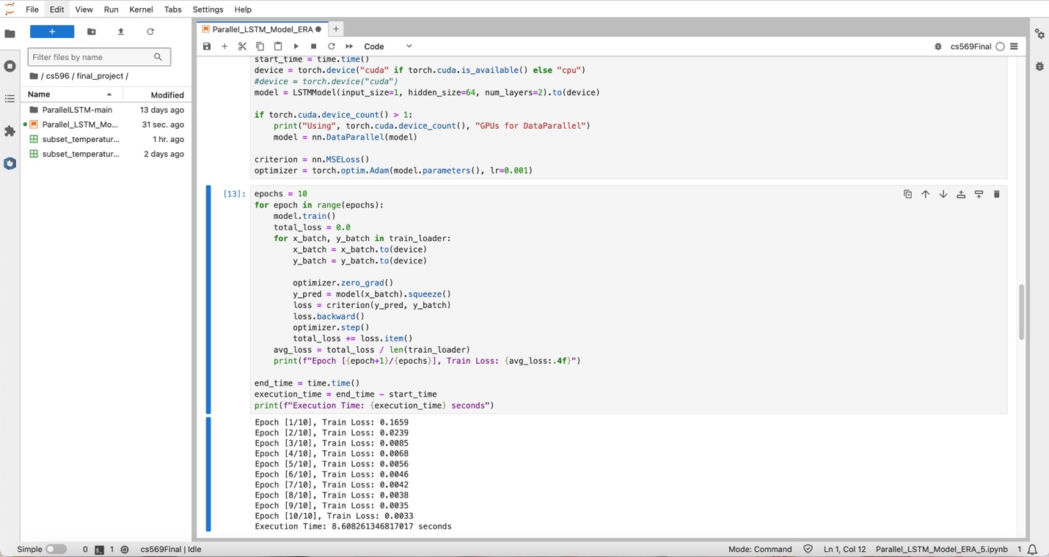

With epoch = 15, execution time: 11.89s

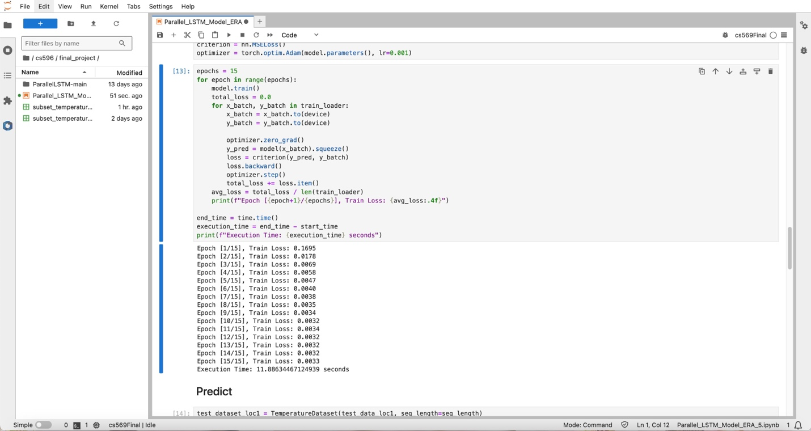

With epoch = 20, execution time: 16.45s

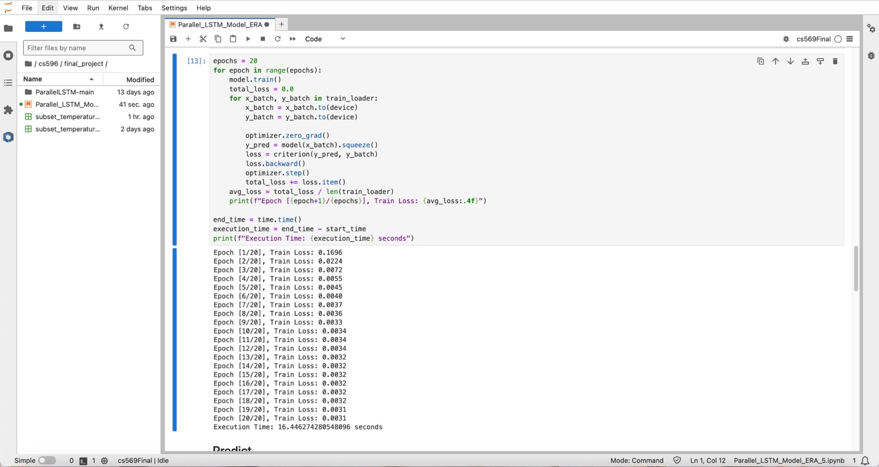

GPU: A40

CPU = 2

Num_worker = 1

With epoch = 5, execution time: 3.91s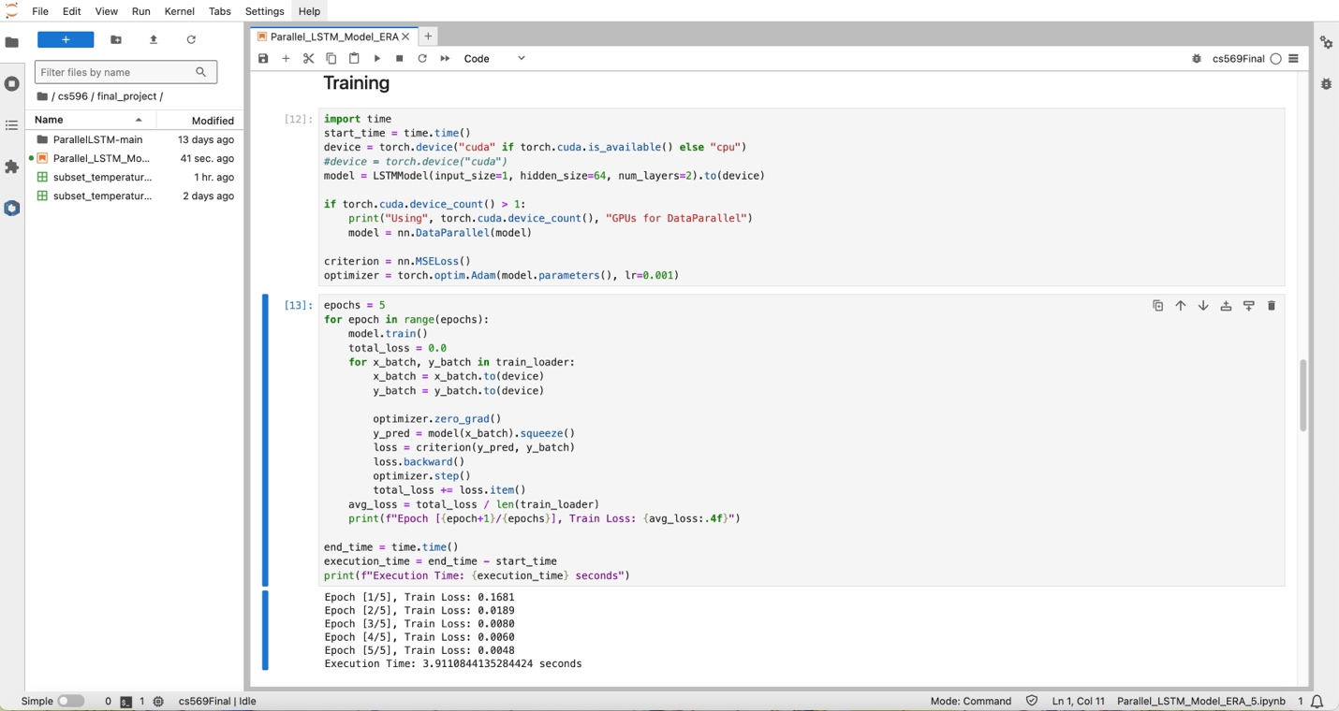

With epoch = 10, execution time: 6.52s

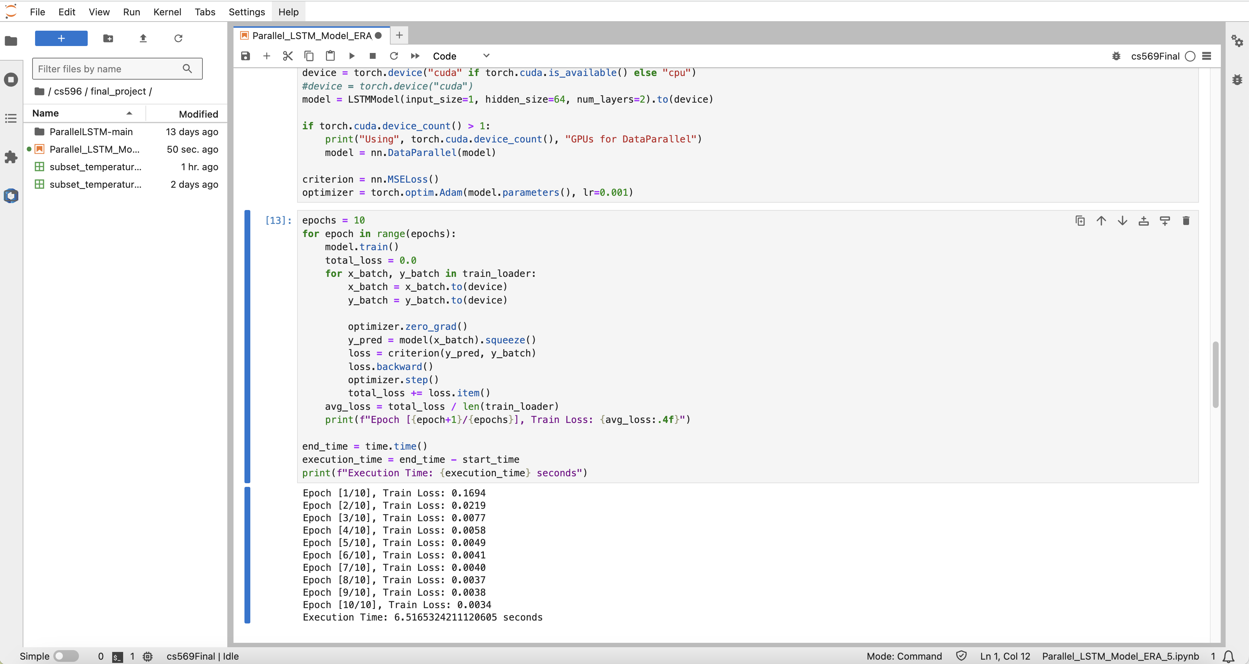

With epoch = 15, execution time: 8.58s

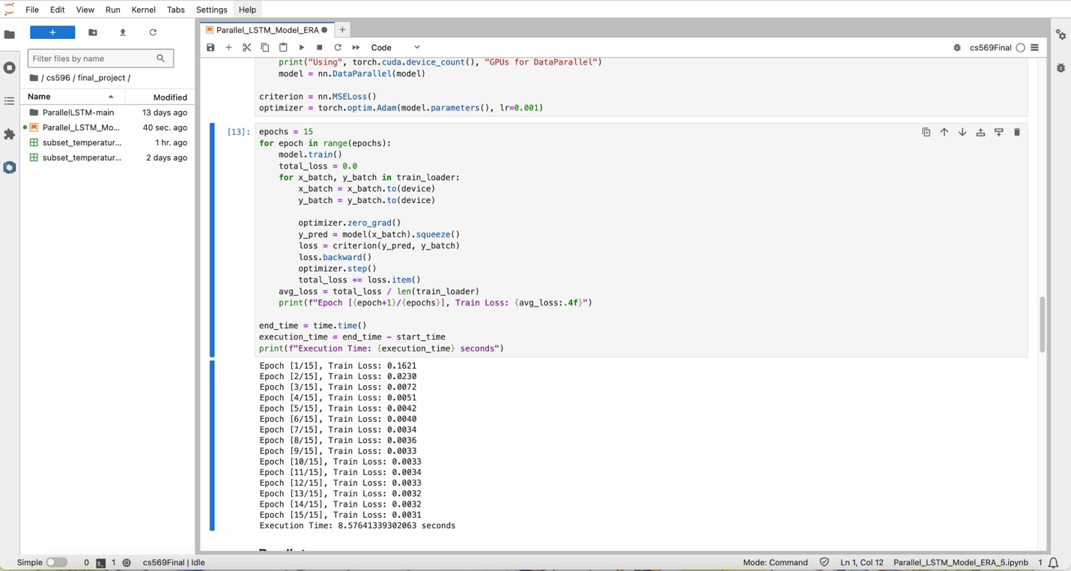

With epoch = 20, execution time: 11.67s

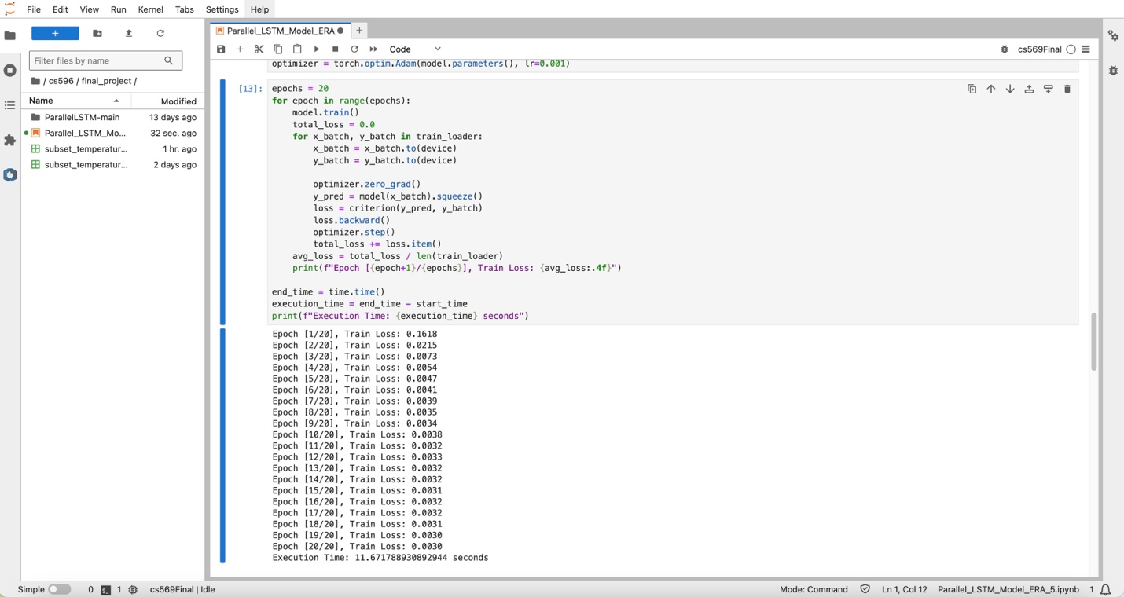

Num_worker = 2

With epoch = 5, execution time: 4.34s

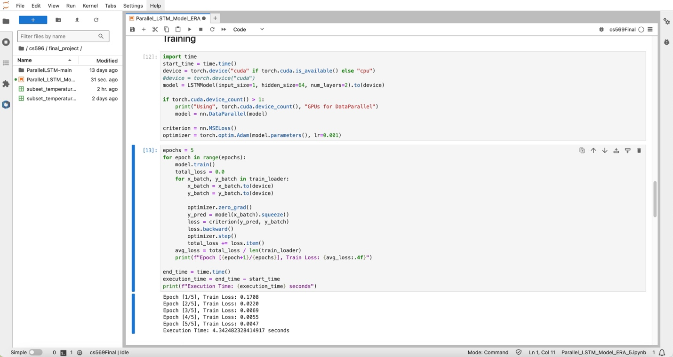

With epoch = 10, execution time: 6.49s

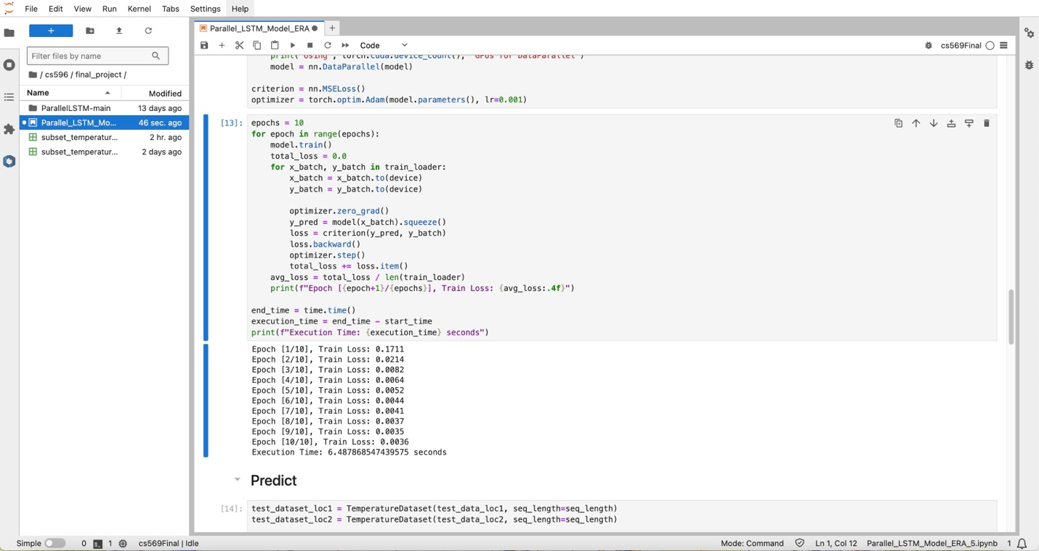

With epoch = 15, execution time: 9.58s

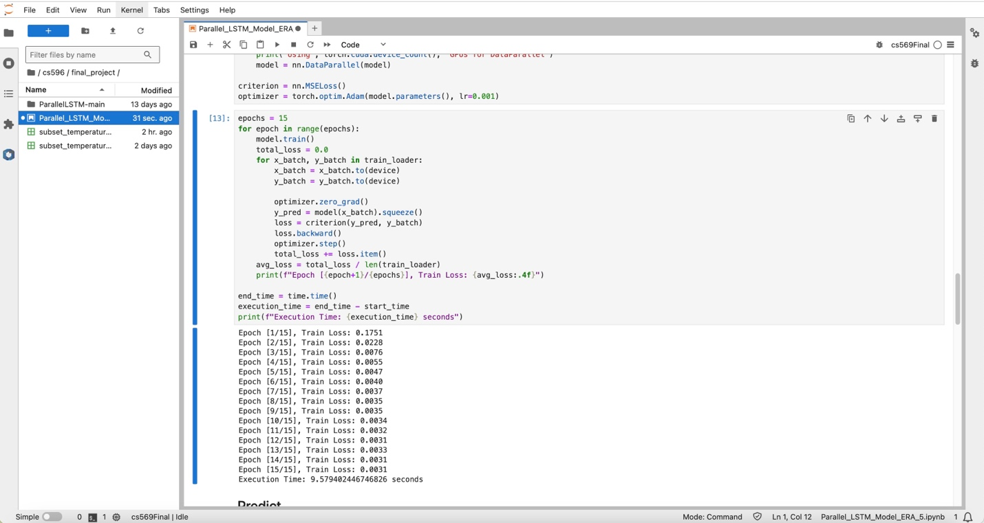

With epoch = 20, execution time: 12.13s

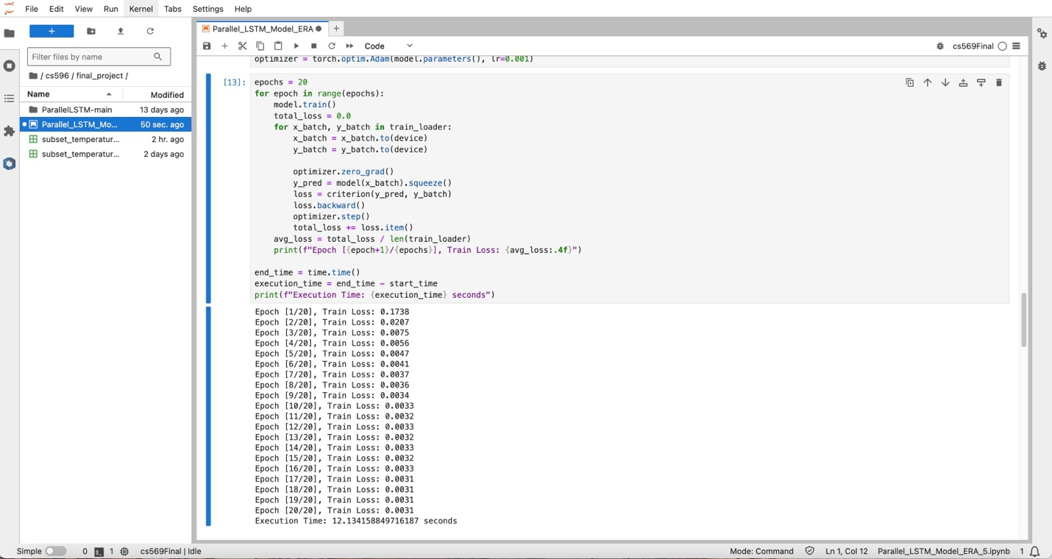

GPU: A100

CPU = 2

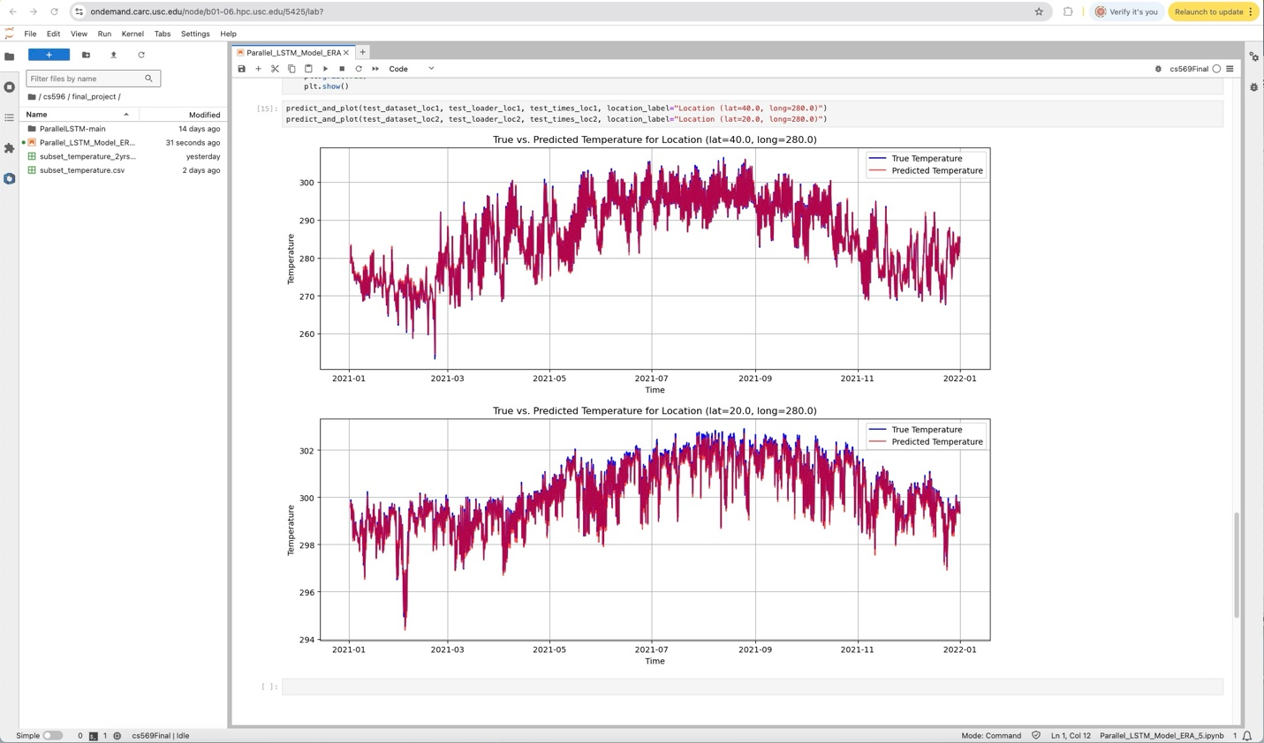

Num_worker = 1

With epoch = 5, execution time: 5.14s

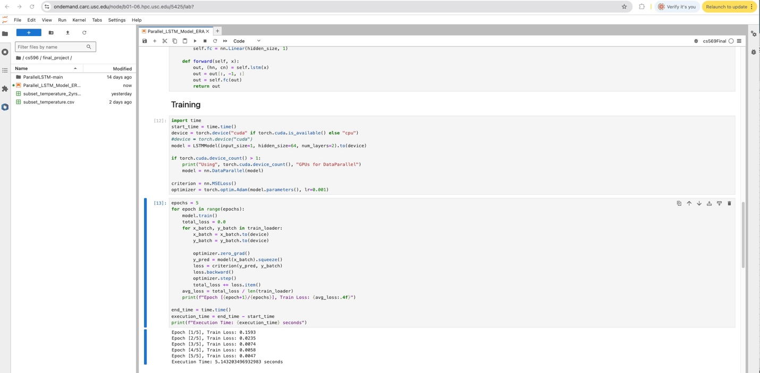

With epoch = 10, execution time: 8.98s

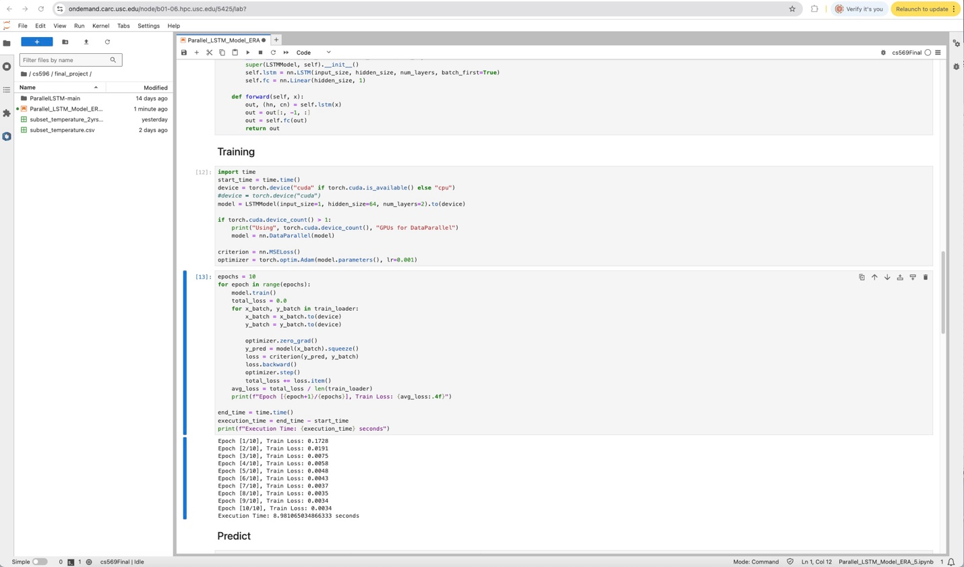

With epoch = 15, execution time: 11.65s

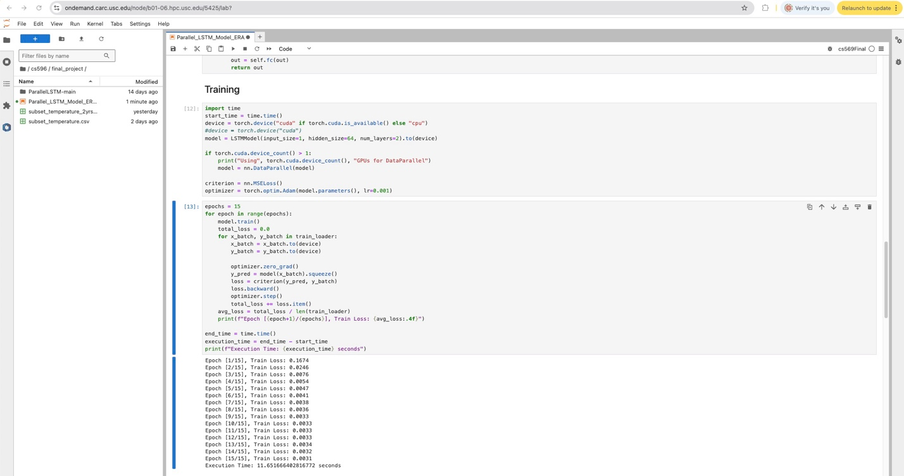

With epoch = 20, execution time: 16.39s

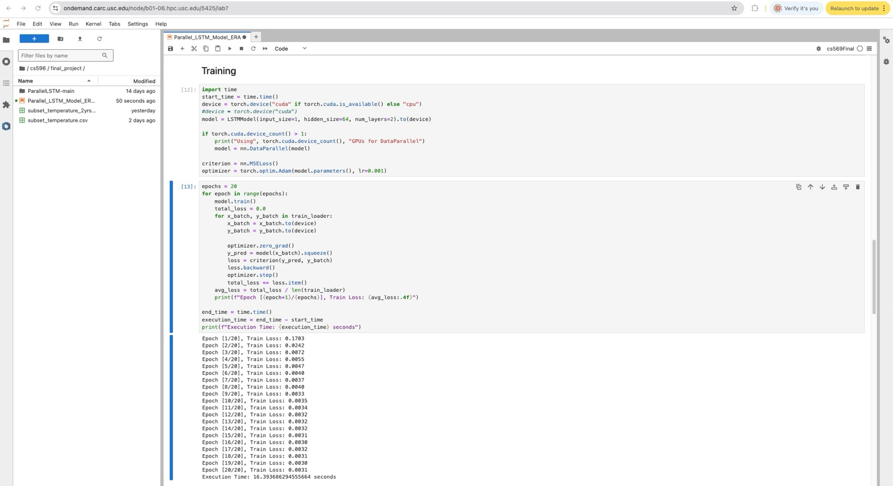

Num_worker = 2

With epoch = 5, execution time: 4.66s

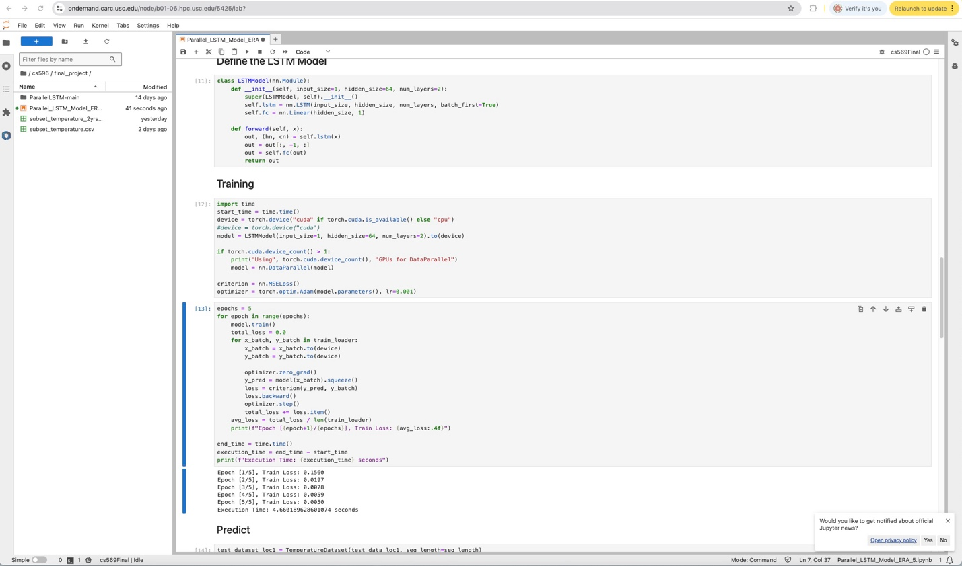

With epoch = 10, execution time: 9.07s

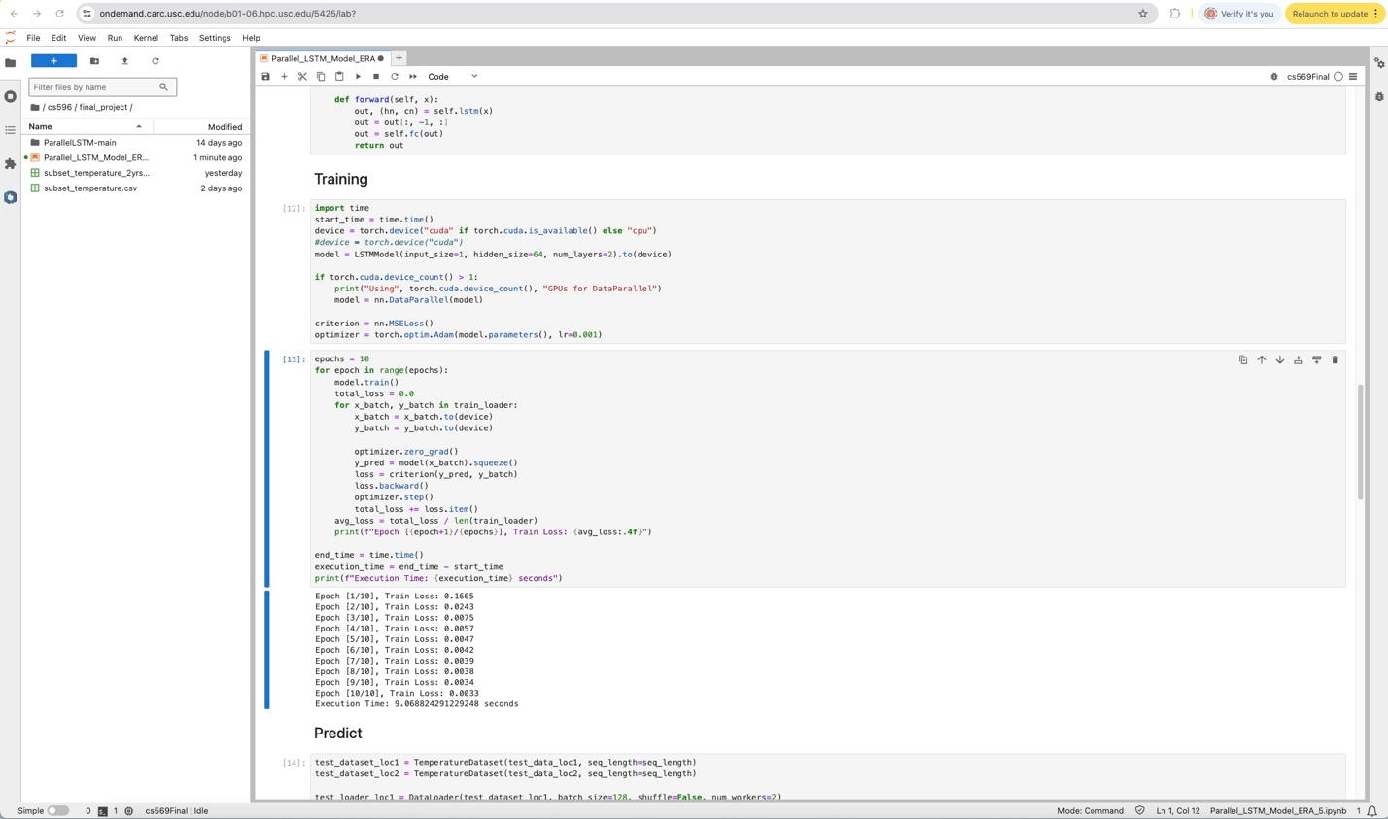

With epoch = 15, execution time: 12.43s

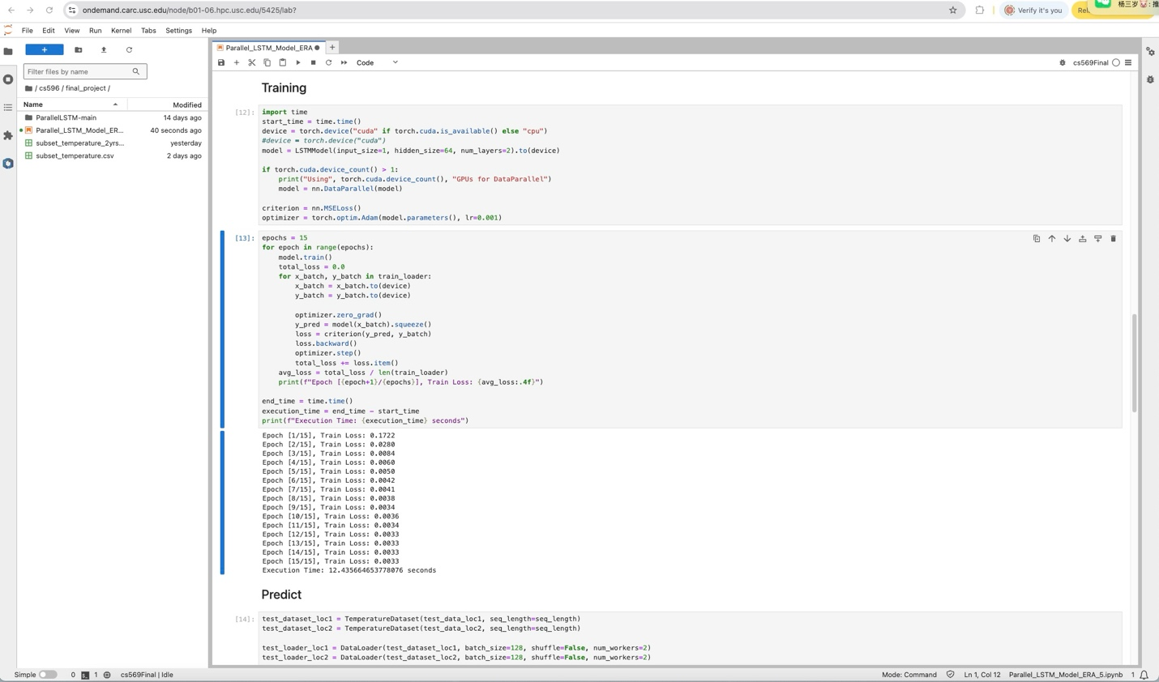

With epoch = 20, execution time: 16.40s

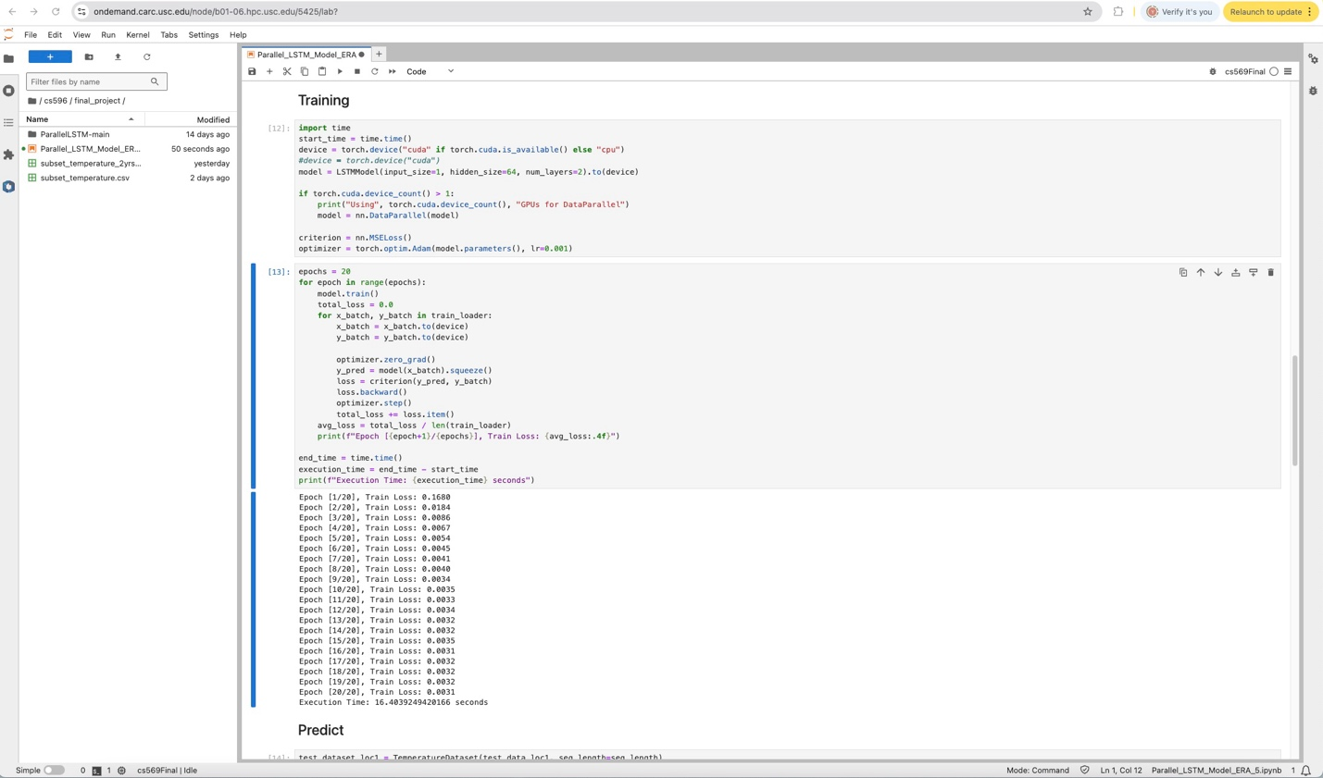

GPU: P100

CPU = 2

Num_worker = 1

With epoch = 5, execution time: 4.12s

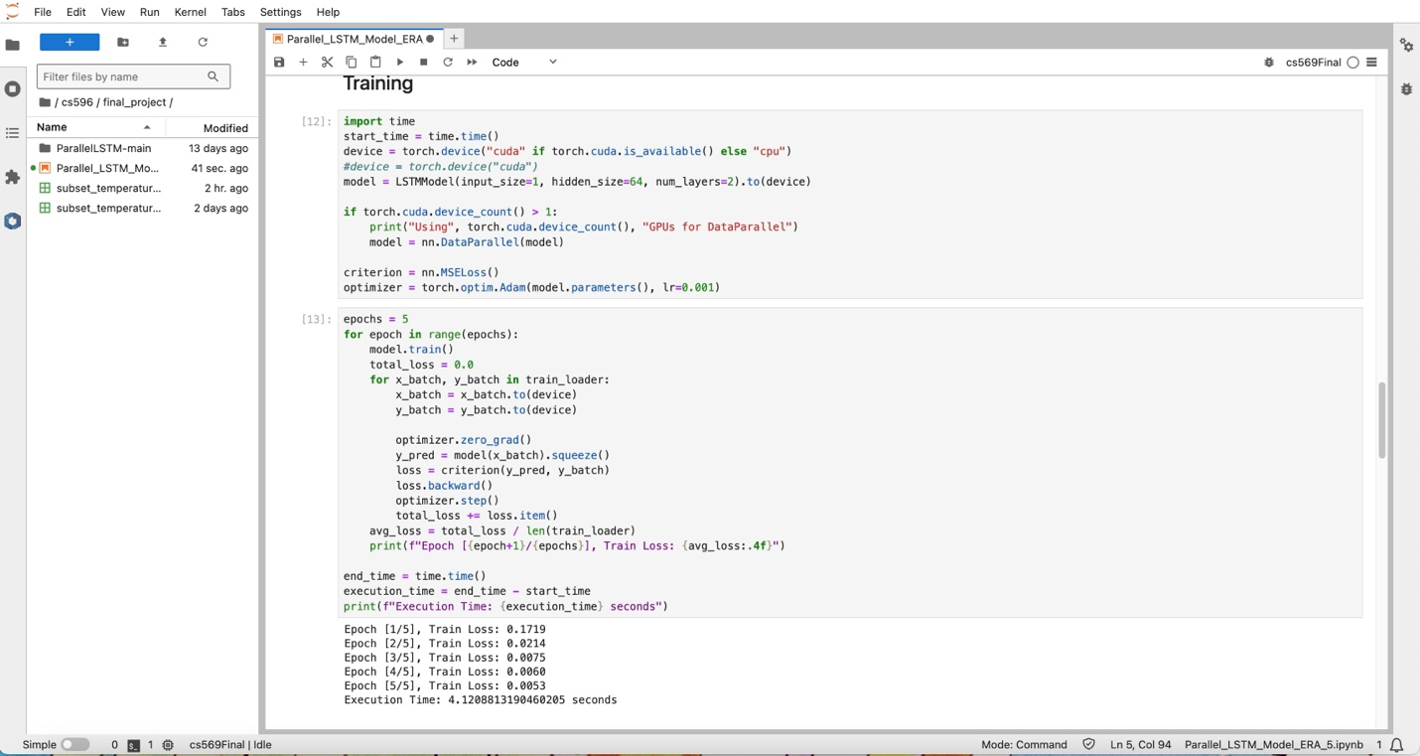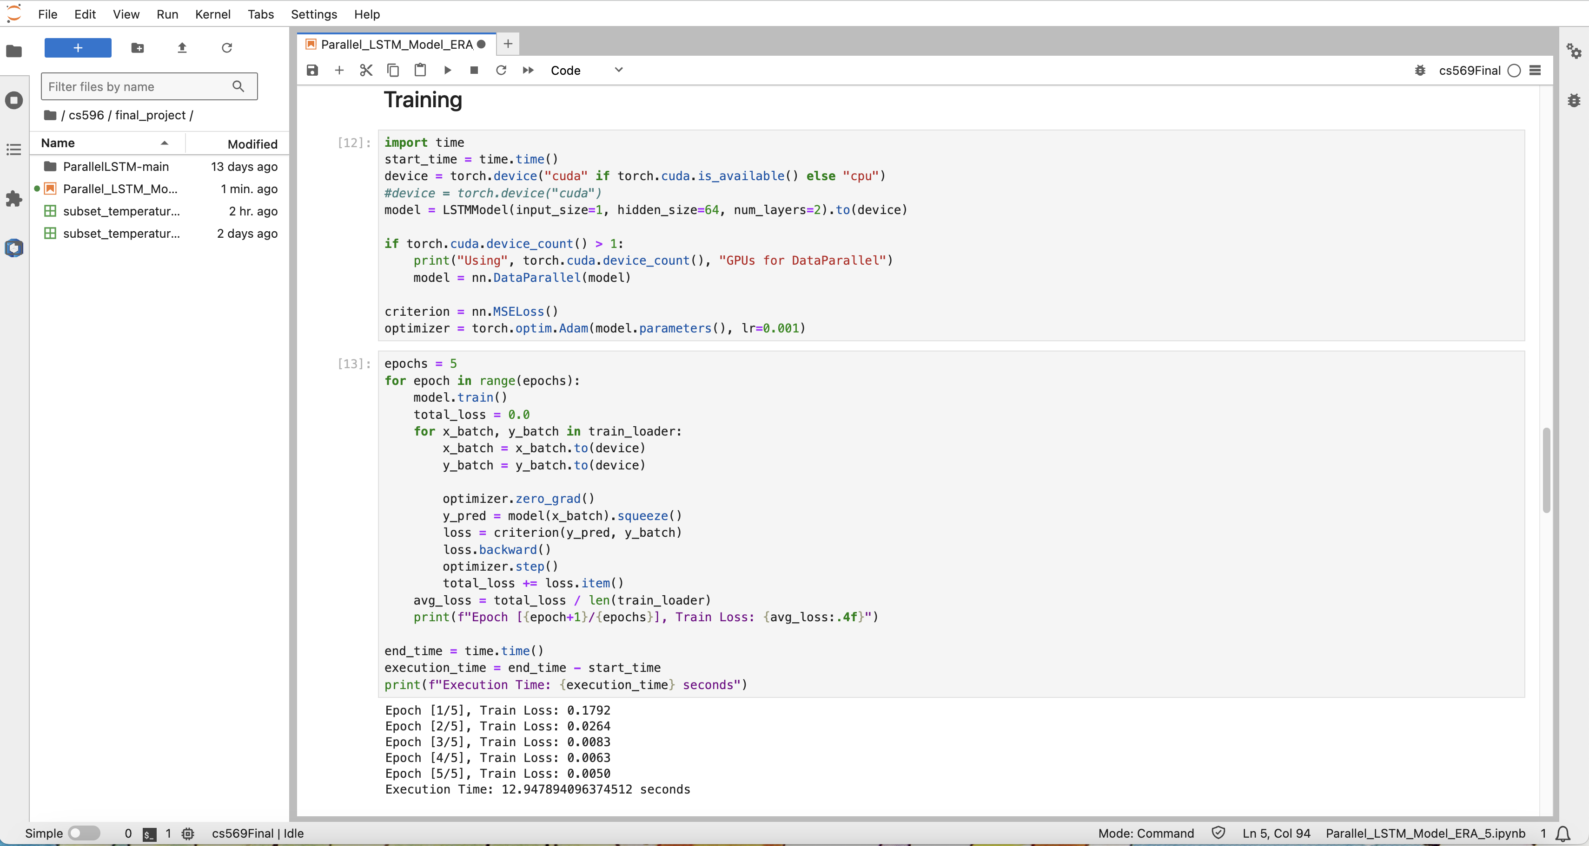

With epoch = 10, execution time: 7.69s

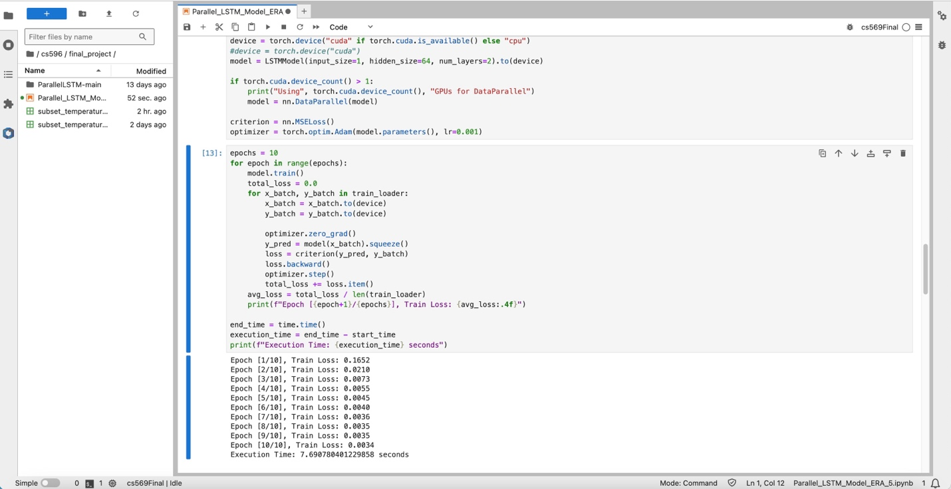

With epoch = 15, execution time: 9.72s

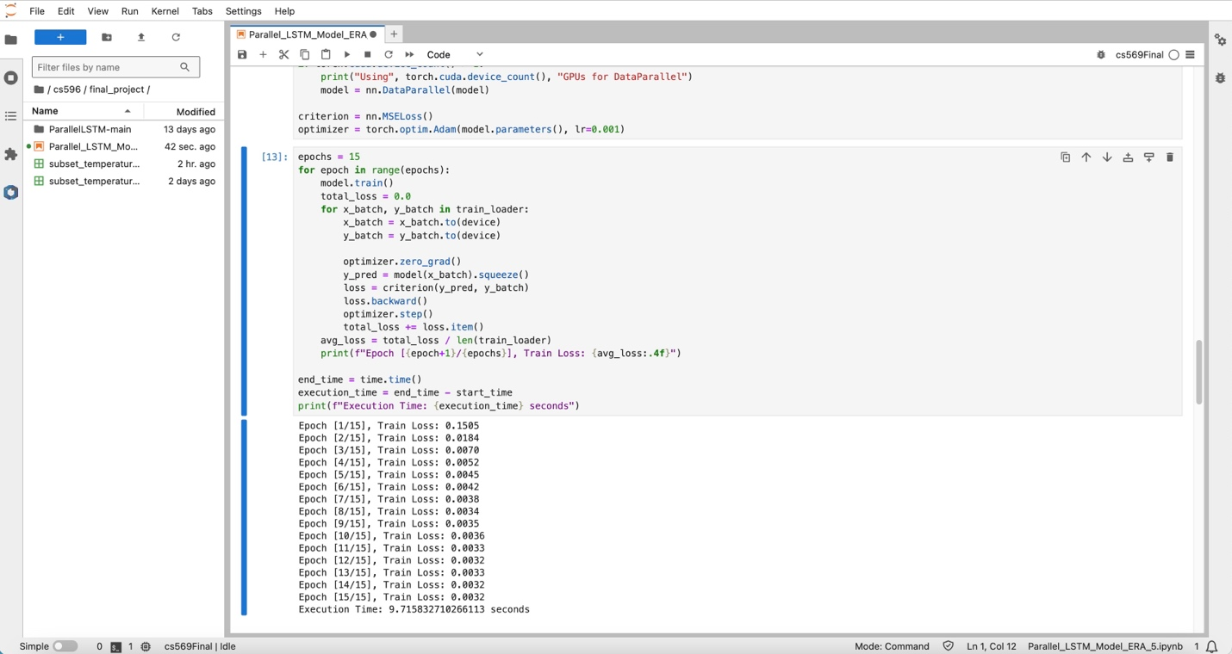

With epoch = 20, execution time: 13.12s

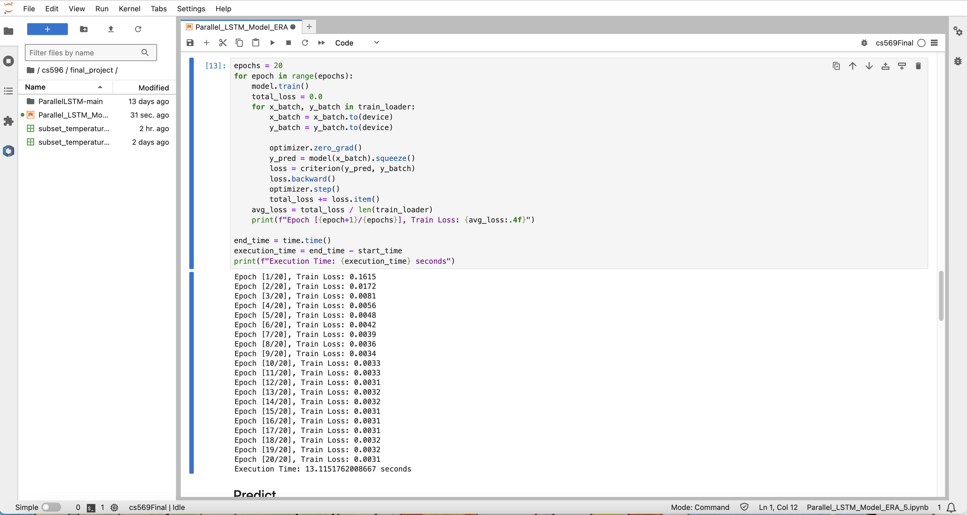

Num_worker = 2

With epoch = 5, execution time: 4.52s

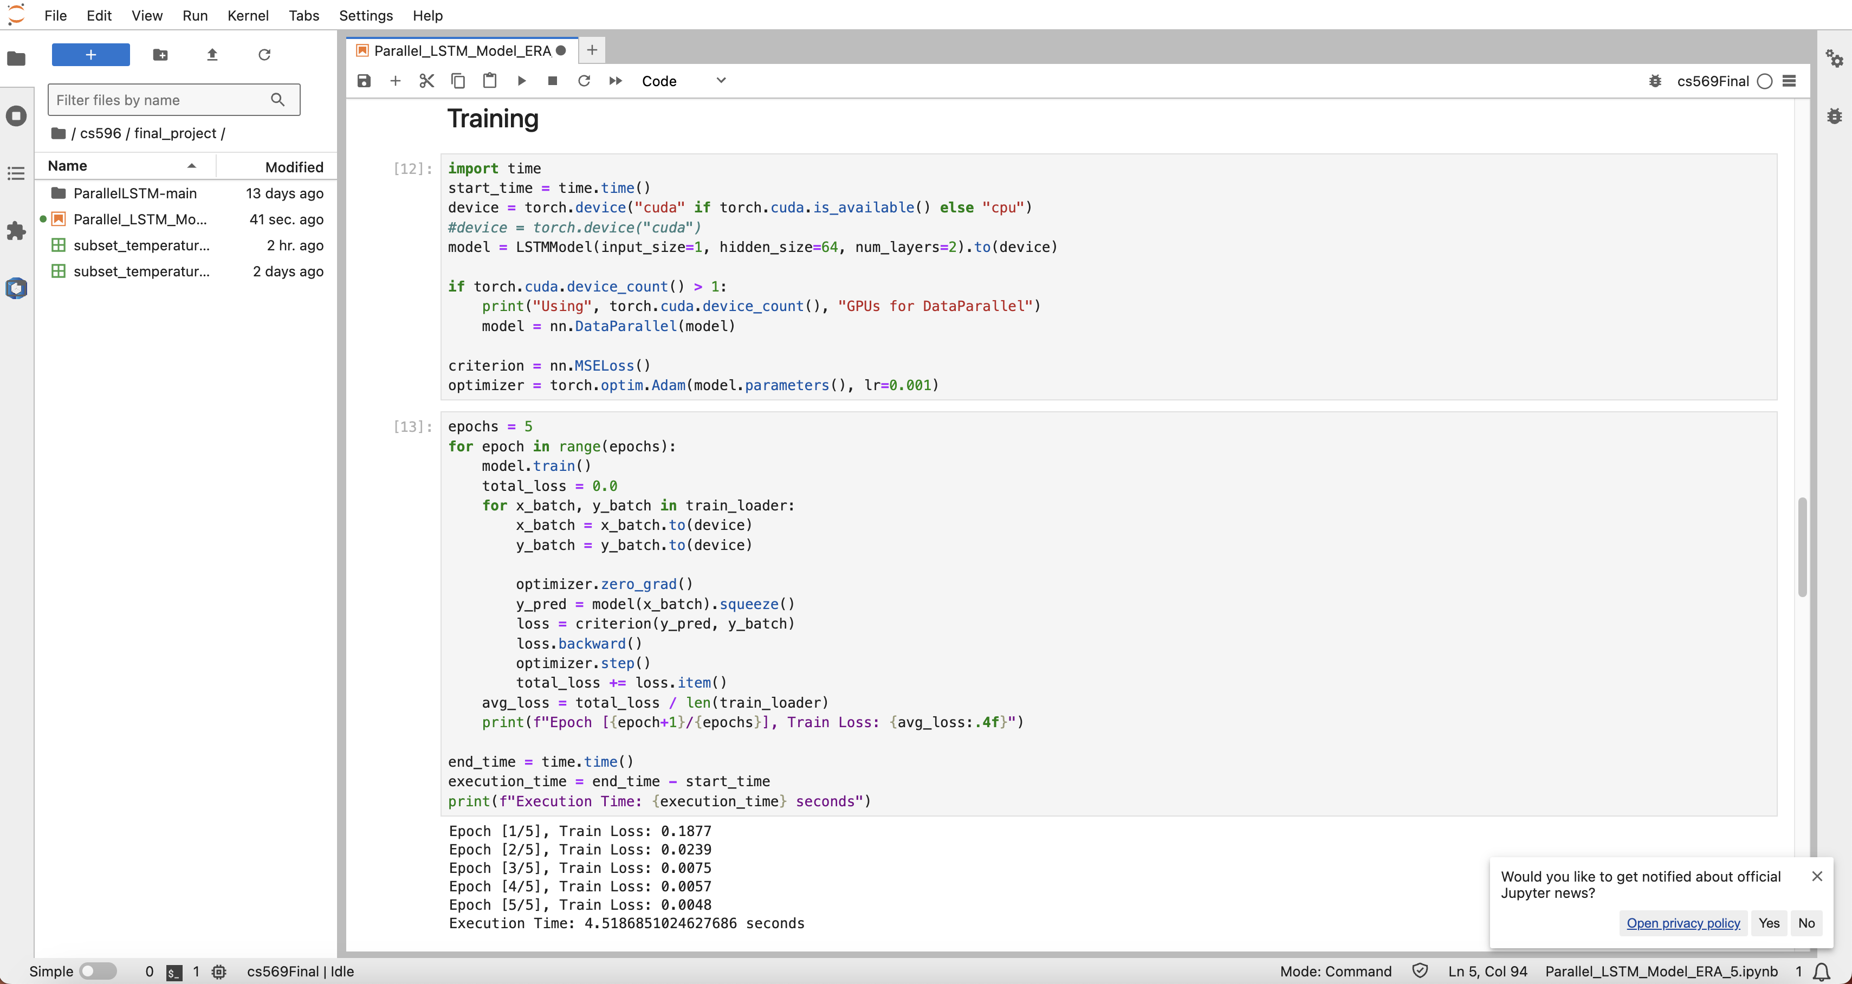

With epoch = 10, execution time: 7.39s

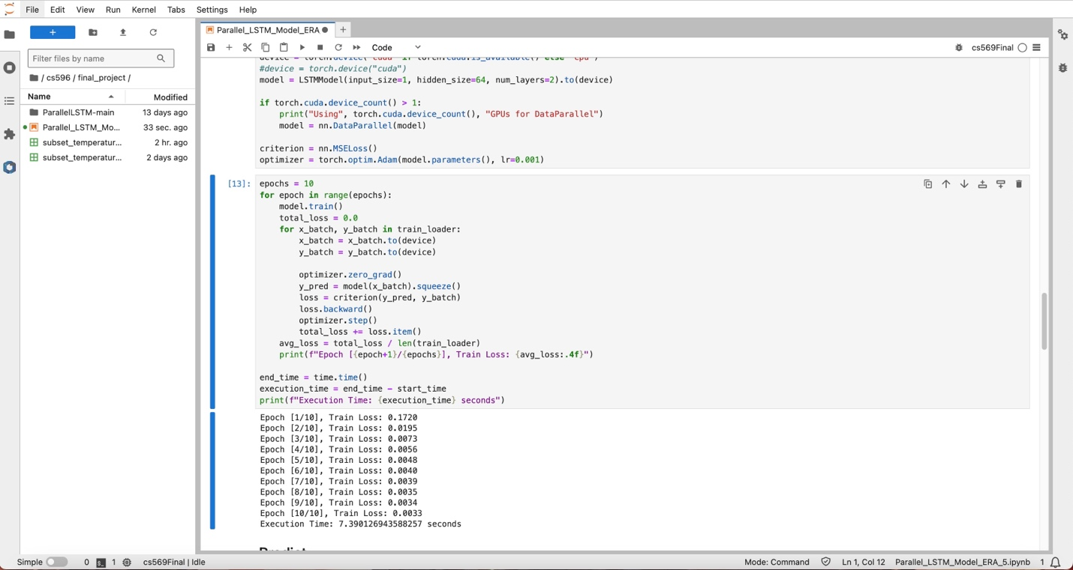

With epoch = 15, execution time: 10.04s

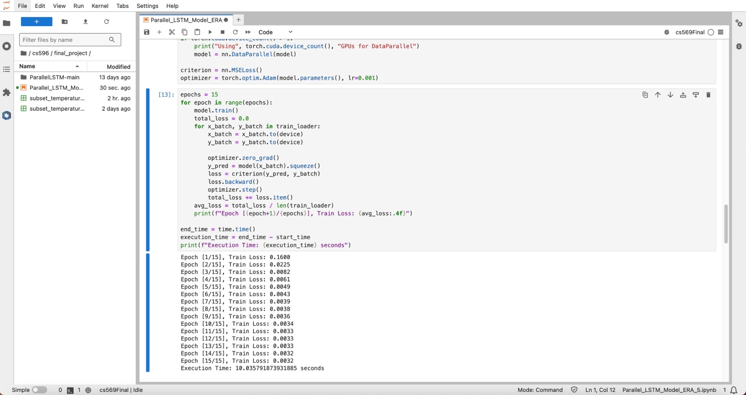

With epoch = 20, execution time: 12.66s

